**Forgot-password process**

* Click on the **Forgot Password** link on the Sign-in page.
* You will land on the Forgot Password page. 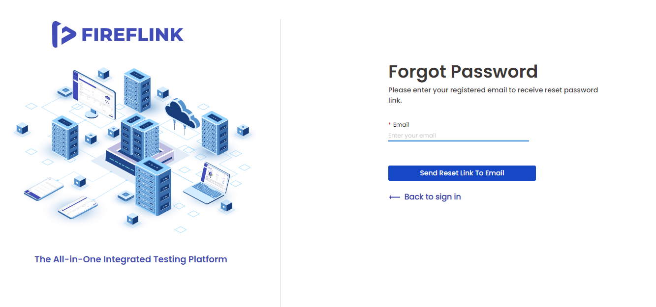
* Enter the valid **Email Id** in the Email text field.
* Click on **Send Reset Link To Email** button.

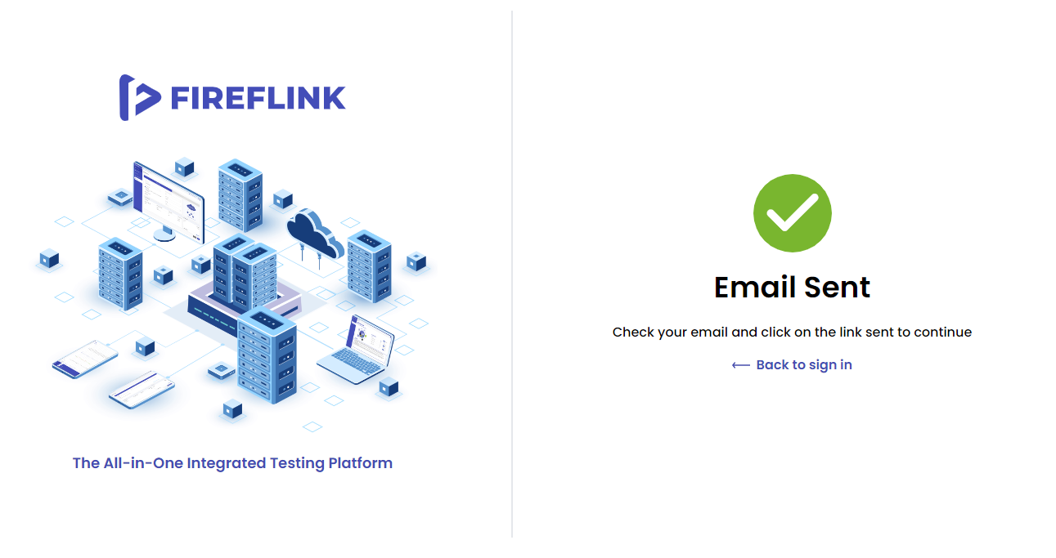

* You will get an **Email Sent** confirmation on the screen. A **password reset link** will be sent to the given email id.In the email you’ll have a Set **Password** link and **Contact Us** link.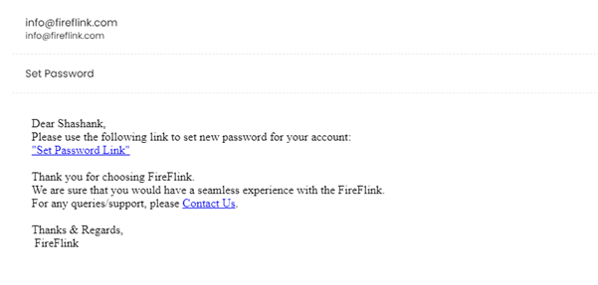
* Upon clicking on the Contact **Us** linkin your email, you will be navigated to our website. 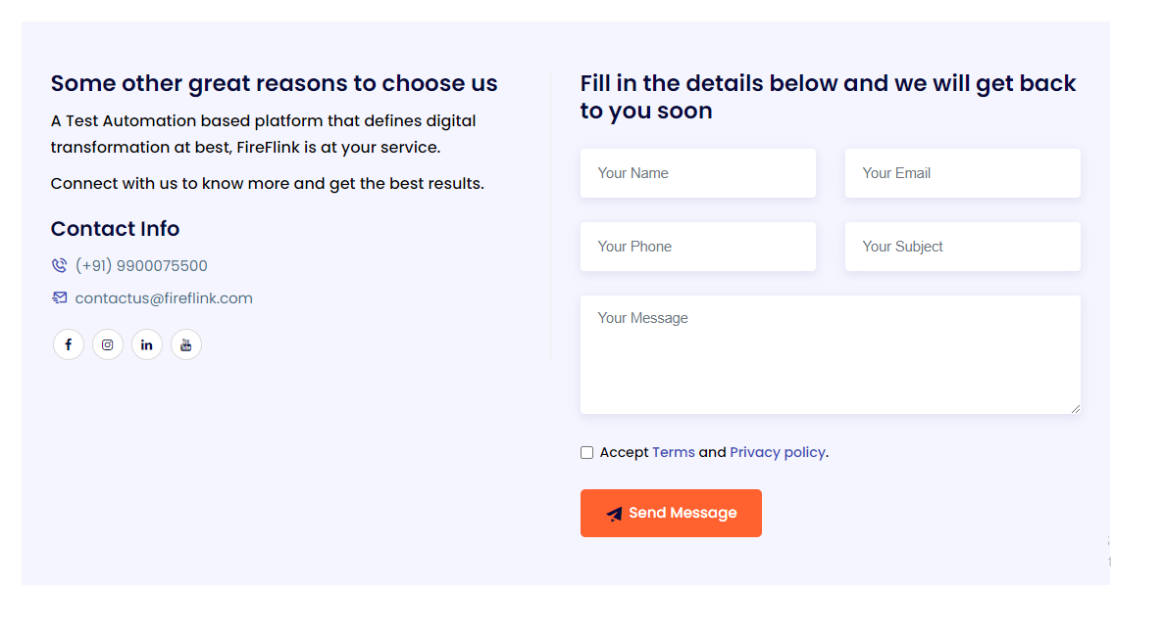
* Upon clicking on **Set Password Link**, you will be navigated to the Set Password Page. 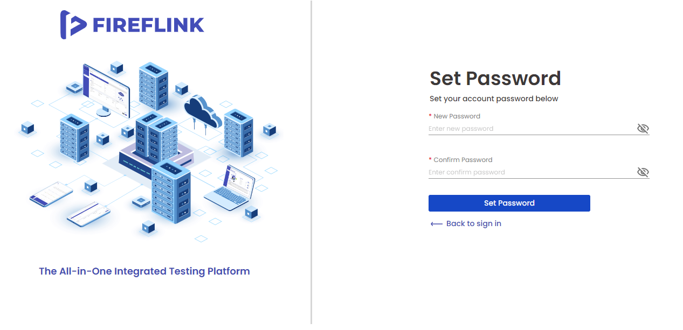
* Enter your **New password** in the New Password text field.
* Enter the same password in the **Confirm Password** text field.
* Click on the **Set Password** button.
* You will get the Password Set Successfully page.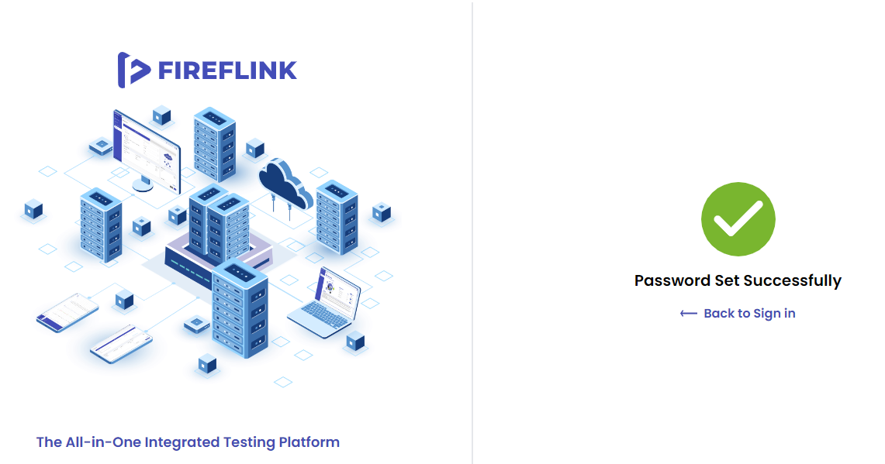
* With this, the user will receive a FireFlink Password set successfully e-mail.
* Click on the **Back to Sign in** Link.
* You will be landed on the Sign in page. Now, enter the registered email with the newly set password. The user will be able to log in with the new password.

**How to change the registered phone number process**

* Click on the **'Click here**' link on the Verification Code page.

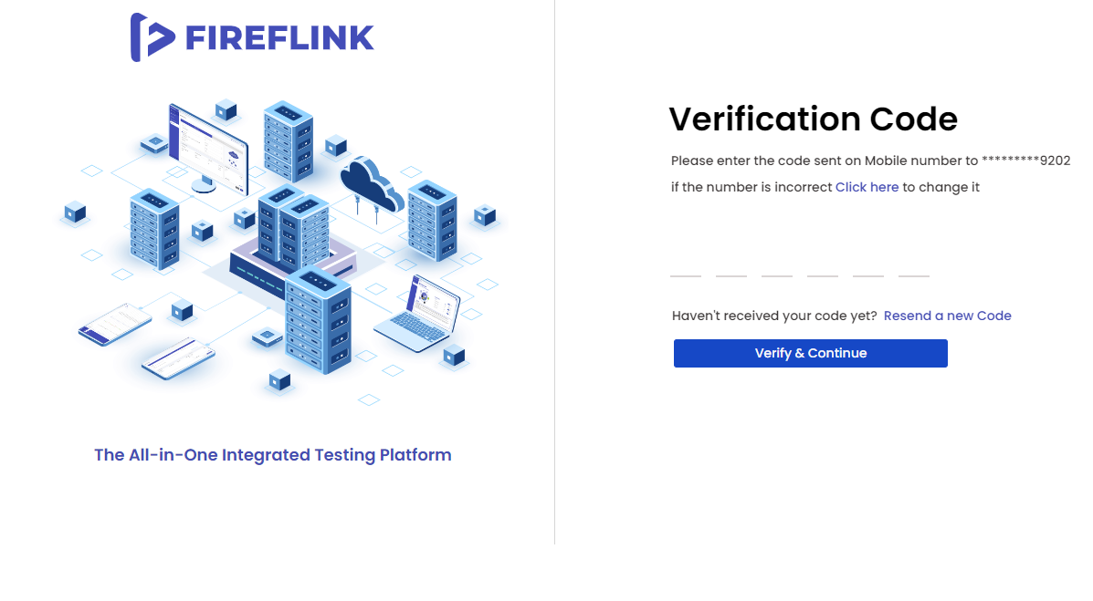

* You will land on the Phone Number page.

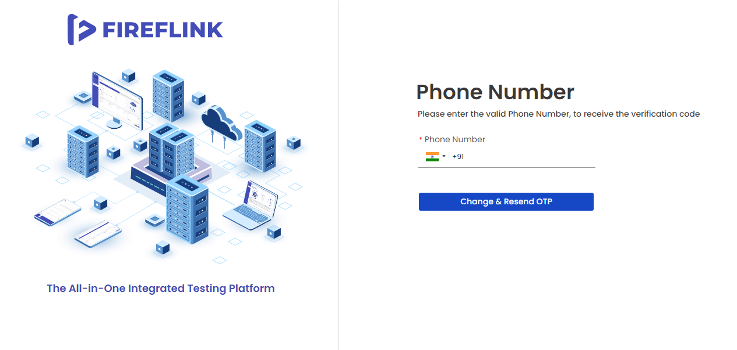

* After selecting country from the country dropdown, enter a valid Phone Number and click on the **Change & Resend OTP** button. An OTP will be sent to the new phone number, and you will be navigated to the **Verification Code** Page.
* Phone number changed successfully message is displayed for the user.
* Enter the OTP sent to your new number, and click on the **Verify & Continue** button.

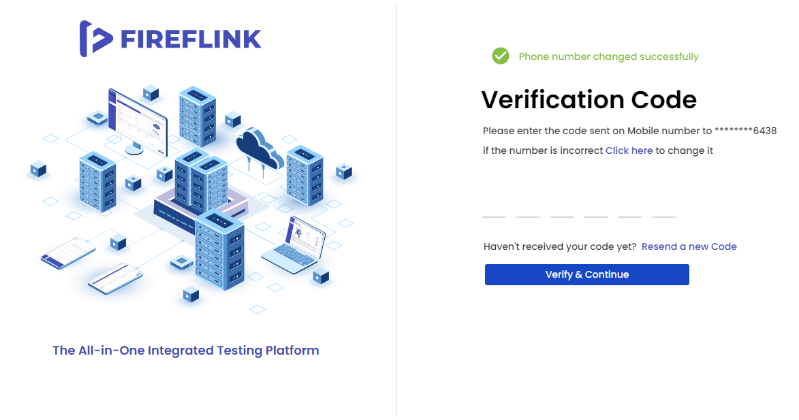

* Upon clicking on **Resend a new Code** Link a new OTP will be sent to the Phone Number.
* You will navigate back to the Verification Code page.
* You will get an OTP to the newly entered phone number. Enter that OTP on the Verification Code page.
* Click on the Verify & Continue button.
* You will land on the Sign-in page.
* The user will receive, a FireFlink account activation successful mail